The Effects of Climate Change on Wildlife and Landscapes- how do we respond faithfully to the challenge?

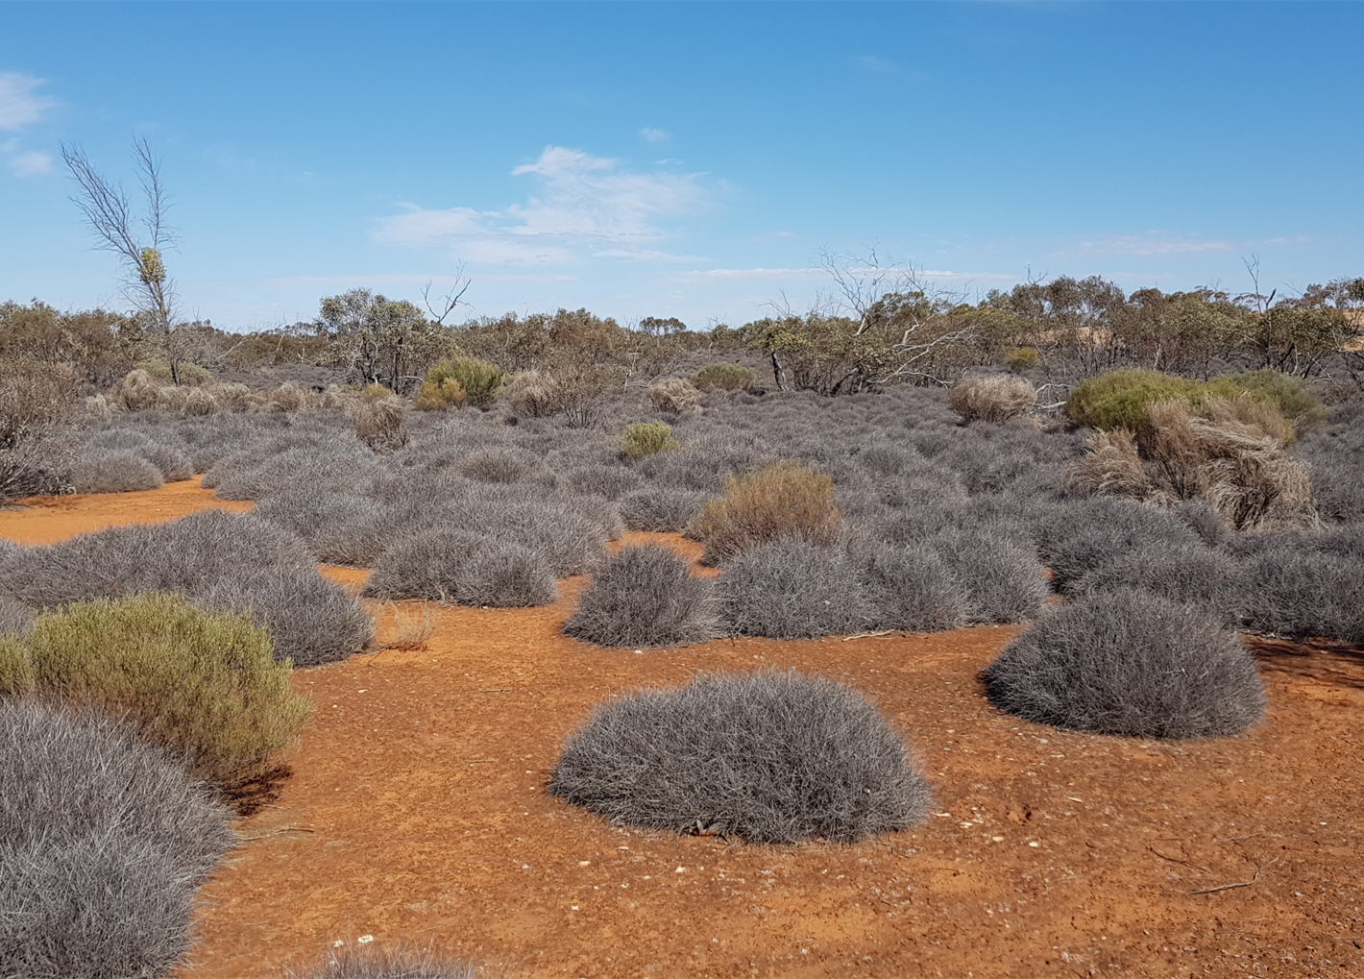
The Climate Action Group of the Banyule Network of Uniting Churches is hosting a presentation and discussion led by two senior scientists who have devoted their careers to conserving Nature.
Prof Andrew Bennett and Prof Michael Clarke (see below) will share their understanding of some of the current challenges to the natural world posed by climate change and how they, as Christians, see this connecting with their faith and their responsibility to care for the planet.
Presentations will be followed by time for questions and discussion.
Date and Time: Tuesday 8th August, 7:30-9pm
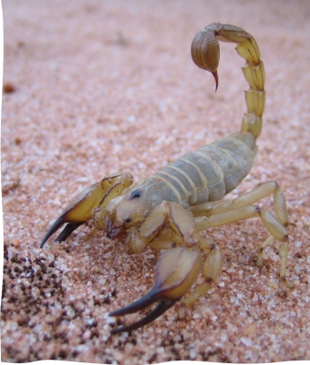
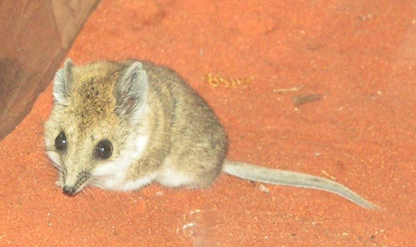
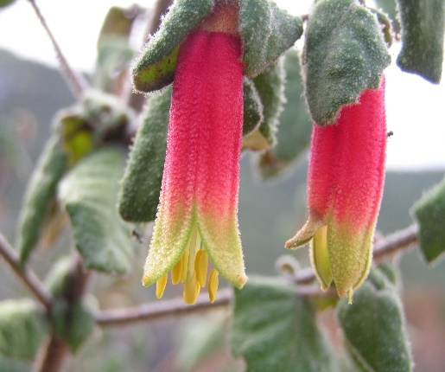
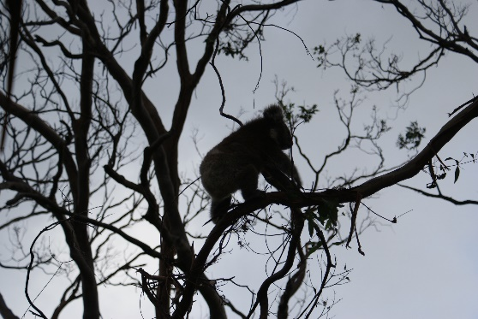
Venue: Cross Generation Uniting Church, Cnr Edwin and St Hellier Streets, Heidelberg Heights AND online via the following link on Zoom (left click link while holding down Control key) : https://us06web.zoom.us/j/2356821947

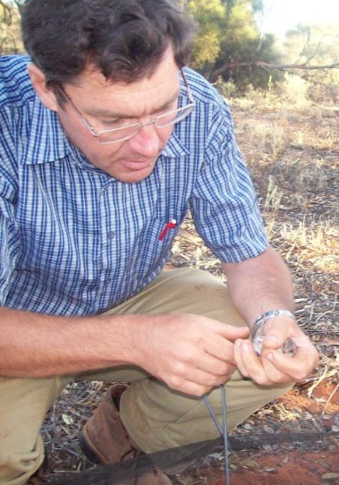
Professor Andrew Bennett
Professor Andrew Bennett completed a BSc (Hons) and PhD at the University of Melbourne and worked for 12 years in wildlife research at the Arthur Rylah Institute for Environmental Research (Victorian State Government). In 1996 he moved to Deakin University and in 2008 was awarded a Personal Chair in Landscape Ecology. In 2015, he commenced a joint appointment as Professor of Ecology at La Trobe University and a Science Leadership role at the Arthur Rylah Institute. He has broad interests in landscape ecology and conservation biology, with a particular focus on understanding how human land-use and landscape change affect native wildlife and ecological processes. Together with colleagues and research students, he has investigated factors that influence wildlife conservation in agricultural landscapes, the effects of fire on biota (in ecosystems ranging from semi-arid mallee, to box-ironbark and foothill forests) and the conservation biology of numerous species of birds and mammals. Six-month study periods in Canada (Carleton University, 1989), Britain (Monks Wood, Centre for Ecology & Hydrology 2000) and USA (Harvard Forest, 2012) have been formative experiences. He is a Fellow of ISCAST (Christianity and Science in Conversation). https://scholars.latrobe.edu.au/display/afbennett

Professor Michael Clarke
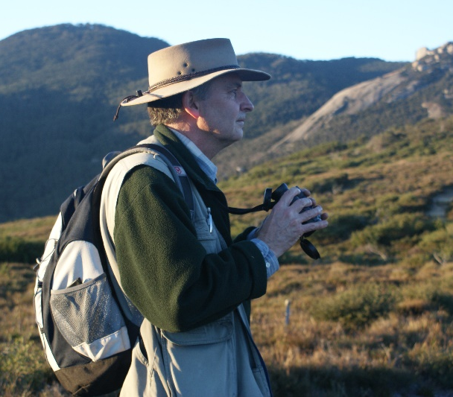
Emeritus Professor Mike Clarke is a zoologist who has studied the ecology and conservation biology of birds, reptiles, mammals, fish and plants. He leads research at La Trobe University, along with his colleagues Profs Andrew Bennett and Jim Radford into the impact of fire on fauna. He also maintains an ongoing research interest in threatened species and threatening processes. He was the Convener of the Scientific Advisory Committee on the Flora and Fauna Guarantee Act to the Victorian Minister for the Environment for five years. In 2007 he was awarded the DL Serventy Medal by the Royal Australasian Ornithologists Union for his outstanding contribution to the scientific literature in ornithology. In 2010 he was an expert witness in fire ecology at the Victorian Bushfires Royal Commission. He was the Head of the School of Life Sciences from 2011-2019. In 2014 his research on fire ecology with Prof Bennett was one of three finalists for a Eureka Prize in Environmental Research. In 2023 he was elected as a Fellow of Birdlife Australia, the highest award available in the discipline, for distinguished service to ornithology. He remains actively involved in research and ensuring conservation policy is based on the best available evidence. He serves as a member of the Board of Directors for Parks Victoria. He is a Fellow of ISCAST (Christianity and Science in Conversation). https://scholars.latrobe.edu.au/mfclarke

