Uniting Church in Australia
Synod of Victoria and Tasmania
brunswick uniting church
ABN 88 977 271 107

214 Sydney Road
Brunswick
PO Box 293
3 August 2022

Brunswick VIC 3056
BUC Missional Appeal – a letter from the Co-Chairs
Dear members and friends of Brunswick UC,
As Shawn said when launching our Missional Appeal on 17 July, thank God for BUC! What an amazing community of communities we have here.
Often we’re so busy “doing stuff”, we don’t notice all the ways we’re engaged in God’s mission. Let’s celebrate, among other things:
- our ministry and mission with children, youth and young adults, both within and beyond the Sunday morning community
- The Olive Way - a midweek community including all walks of life, all faiths and none, rooted in Christian hospitality
- our arts ministries
- our public witness and action on the climate crisis, people seeking refuge, including and celebrating people of all genders and sexualities, justice for First Nations, and much more
- our strong commitment to growing in faith and discipleship, through liturgy & music, sermons, study groups, and more
We have a vision to continue and grow each of these missional areas. But it costs money. A lot of money. And as you know, everything’s getting more expensive, not less.
As we discussed at the AGM in early June, the projected deficits over the next 5 years just keep increasing, if we carry on with all our current plans without raising our income. The congregation decided to:
- pause our search for a new CYYA minister
- run a missional appeal, and
- meet again on 11 September, to make decisions based on what we can afford across all our mission & ministry.
Ian and Shawn launched that Mission Appeal on 17 July. It runs until 21 August.
In the coming weeks, you’ll hear more about the vision in different areas of BUC’s common mission, and what we need to achieve our collective vision. Previous weeks’ messages are up on our website.
You’ll be invited to respond, in a variety of possible ways – see the response form attached. We’ll bring it all together in a celebratory offering of our pledges of support during worship on 21 August.
The main responses we’re looking for are:
- pledges of increased regular giving (weekly, monthly or annually)
- pledges and immediate donations to our new Current Mission Fund, which ideally will offset any deficits for at least the next 5 years (see the Olive Branch for August)
Can you help us achieve our shared goals for ministry and mission at BUC?

We want to say a few other things about this Missional Appeal, on behalf of Church Council.
Yes, we do want money – not just time, talents and prayers, as important as these are. We want to be direct and not embarrassed about this, and Ian will be speaking about how we as Christians should be relating to money during this appeal season (spoiler: no prosperity gospel!).
However, we are well aware that for some, giving more money just won’t be possible, due to financial circumstances. Some may even find they need to give less than they used to. (With this in mind, we invite those who can give extra to think about helping to “cover” for those who can’t.)
Also, many of us give generously, but to a range of missional organisations – not just through BUC.
We honour and respect those financial constraints and those missional choices. We don’t keep tabs on who gives what, and we are one family in Christ regardless of our giving.
In the end, all our giving is a free choice to give back some of what we have received. Ultimately, it all comes from God and it all belongs to God.
Whatever you can give, we need to hear from you. We need to have a clear idea about what the next five years will look like financially – will we have more income and/or missional reserves, and how much? Then can we make wise decisions at the 11 September congregational meeting.
So please, use the response form attached to let us know what you’re able to give. You can print it out and bring it to worship on 21 August. Or you can fill it in electronically and email it to us at any time (send it to brunswick.uc.treasurer@gmail.com). You’re welcome to make it anonymous, if you prefer.
We both joined BUC at about the same time, delighted to find such a welcoming and active church. It’s wonderful to be part of a vibrant, creative, and compassionate community that has a strong commitment to social and climate justice. But we also know that it is through our missional programs that these important values and gifts really make an impact.
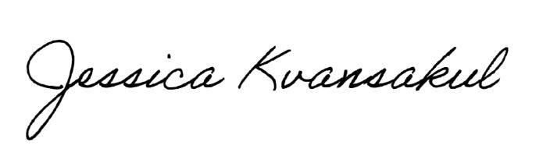
Thank you so much for taking the time to hear our message and consider your response. With your help, we can keep BUC’s important and impactful work going.
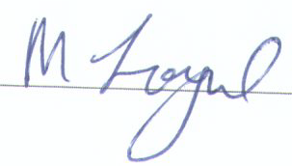
Maxine Loynd Jess Kvansakul
Co-chair, BUC Church Council Co-chair, BUC Church Council
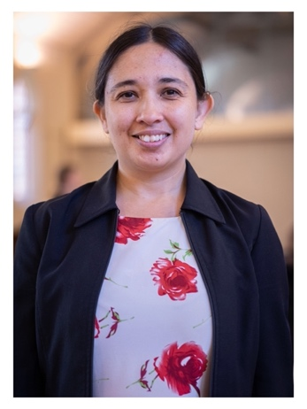
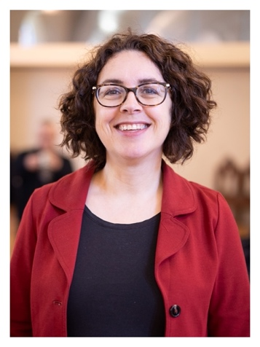

Brunswick Uniting Church

MISSIONAL APPEAL

What’s our vision?
We want to continue being a flourishing “community of communities” in and around Brunswick UC, drawing from and serving the local and wider communities.
Our missional priorities include:
- Olive Way – strengthening leadership, partnerships, volunteer base and activities
- Children and Youth – resourcing our thriving Youth Group, revitalising our ministry with children & families
- Student House – supporting young adults at a critical stage of their life & faith journey
- Food Co-op – exploring new directions and community engagement
- Partnership with Uniting’s Asylum Seeker Programs – finding new opportunities together
- Overall – worshipping together, learning together, caring for each other, and living out our faith through social action and in our daily lives.

What do we need?
To achieve this vision over the next five years, we need a solid ministry team and support staff. The costs of that, along with all other expenses, are increasing.
Without significant changes, we will experience deficits for the next 5 years – from $12,000 this year to $85,000 in the 5th year. We can balance this out if we can achieve either:
- $60,000 per year of additional regular giving (ramping up with $40,000 this year), or
- $20,000 per year additional regular offerings, plus $200,000 in specific donations to the Current Mission Fund this year (to cover the deficits from next year to the 5th year)

Don’t we have a lot of money invested already?
Yes we do. But we need most of those funds to maintain our buildings – the church complex, the student houses, and the minister’s manse. At our recent AGM, the congregation set aside $750,000 for a long term maintenance fund, the income from which should cover much of our “regular” maintenance while the capital is available for big projects, like replacing the slate roof of the hall. Other funds are set aside for projects we’ve already committed to (including the joint project with Uniting to renovate 4 Merri St for their Asylum Seeker Project) or specifically for the Olive Way.
In short, think of it as letting the funds we’ve inherited care for the buildings we’ve inherited. In turn, these buildings are the missional “home base” for us and for generations to come.
So it’s up to us, today’s generation, to raise the funds we need to pay for our missional costs.
Can you step up, and help us achieve our vision?

How can you contribute, over the next 1–5 years?
YES, I will increase my regular giving by:
$ per week, or $ per month, or $ per year (choose one)
YES, I will make a one-off donation of $ to the:
Current Mission Fund (all missional expenditure)
Joan Gilchrist Fund (Olive Way or similar ministries)
Maintenance Fund (current and long-term projects)
I can’t give more money at this time. I will continue to support BUC with my time, prayers and current level of giving.
My financial circumstances have changed, and I need to give less than I have been giving. I will continue to support BUC with my time, prayers and giving as I am able.
Whatever you can offer, thanks very much – from the whole BUC community, and from everyone who participates in our missional activities!

Bequests
Looking a bit further ahead, in addition to the above:
YES, I have put a gift to Brunswick Uniting Church in my will
(approximately $ )
YES, I intend to put a gift to Brunswick Uniting Church in my will
(approximately $ )
NO, I don’t intend to put a gift to Brunswick Uniting Church in my will at this time

Follow up
Would you like further information, conversation or follow up about any part of this response?
YES please! Contact (name) at (details):
No thanks.

