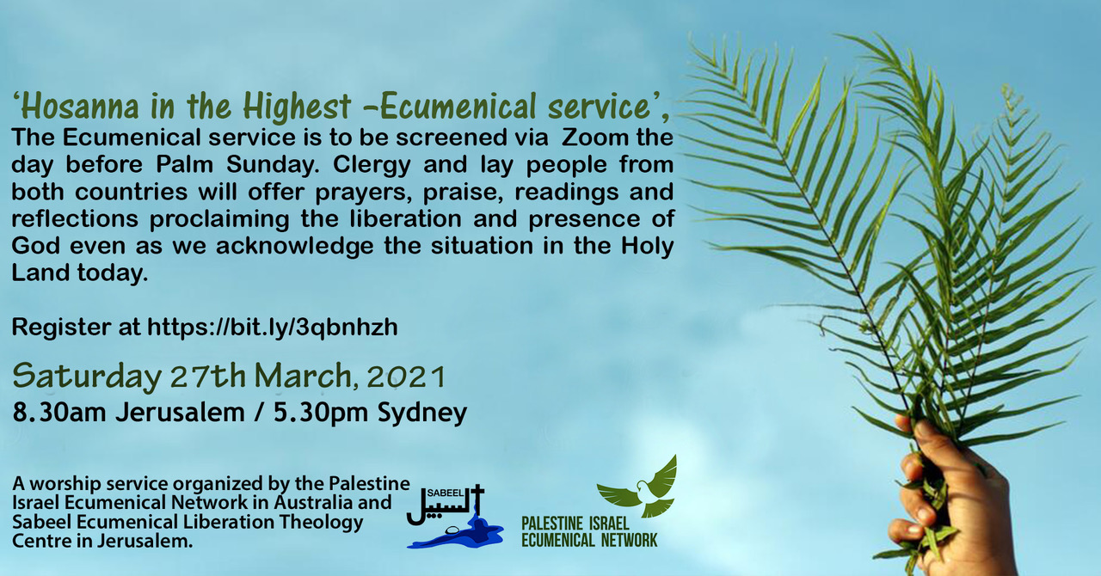
“‘Hosanna in the Highest, Ecumenical Service’ ‘is to be screened via Zoom on Saturday 27th March, the day before Palm Sunday.
5:30 PM Canberra, Melbourne, Sydney / 8.30 AM Jerusalem time

The Palestine Israel Ecumenical Network in Australia and Sabeel Ecumenical Liberation Theology Centre in Jerusalem are organizing a joint Ecumenical service. As we mark the beginning of Passion Week, clergy and lay people from both countries will offer prayers, praise, readings and reflections proclaiming the liberation and presence of God even as we acknowledge the situation in the Holy Land today. This is a unique event providing the opportunity for Christians in Australia and Palestine to worship together at this significant time of the year.

Australian participants in the service include:
Bianca Manning (from Common Grace)
Bishop Richard Condie (Bishop of Tasmania in the Anglican church)
Rob Floyd (Associate General Secretary, Uniting Church in Australia Assembly)
Rev Katherine Rainger (Anglican Diocese of Canberra-Goulburn)
Andrew Menzies (Senior Pastor at Mitcham Baptist church)
And musicians and singers from Brunswick Uniting Church music group.

From Palestine we will be joined by our friend, Areej Masoud, as well as a number of other Palestinian Christians from many denominations that you will have the delight in meeting and hearing from. A very special element will be the Gospel reading from the Church of the Holy Sepulchre (the church that is purported to be the site where Jesus was crucified and the site of his empty tomb). Permission is rarely granted for filming to occur within this sacred church, so we are extremely honoured and grateful for this opportunity. What a significant way for Christians in Australia to see inside this most holy of places at such a commemorative time, particularly as travel to the Holy land is currently unavailable.

Register to attend the hour long service here (please note, it may say the start time is 5pm but this needs to be changed to 5.30pm)

Please invite your friends and share the Facebook event page here.”

.

