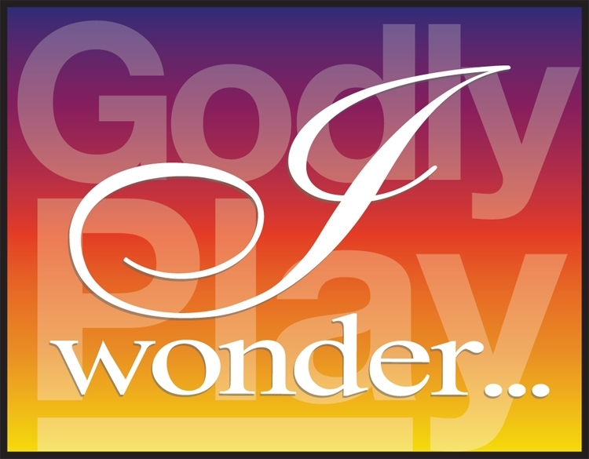
Godly Play
Core Training…
February 2020

Godly Play Core training provides full teacher accreditation in the Godly Play methodology. Core training offers a thorough over-view of the entire teaching method. Each of the language ‘genres’ is examined in detail.
Day one is the language of the Sacred stories from the OT
Day two is the language of Parable and
Day three is the language of Liturgy.
We explore the setting up of the sacred space, and ask how it also ‘speaks’.
We will examine the theology and the spirituality of the child and building of the community circle.
Written by the Rev’d Dr Jerome Berryman (USA) this method is based on the work and wisdom of Dr Maria Montessori (1870-1952).
For more information: godlyplay.org.au and there are many international sites too. This is a beautiful presentation from Germany (in English).
https://www.youtube.com/watch?v=py6vzIs_NcM
Written by the Rev’d Dr Jerome Berryman (USA) this method is based on the work and wisdom of Dr Maria Montessori (1870-1952).
Attendance for the full three days is a requirement for certification.

When? February 13,14 & 15
Where? Centre for Theology and Ministry, 29 College Crescent Parkville
Who is it for? This course is for anyone interested or involved in ministry within the church.
Details? Contact Jeanette Acland jeacland@gmail.com 9349 1182
Cost? Full: $650 for the three full days. Concession: $450
Please contact Jeanette for further details
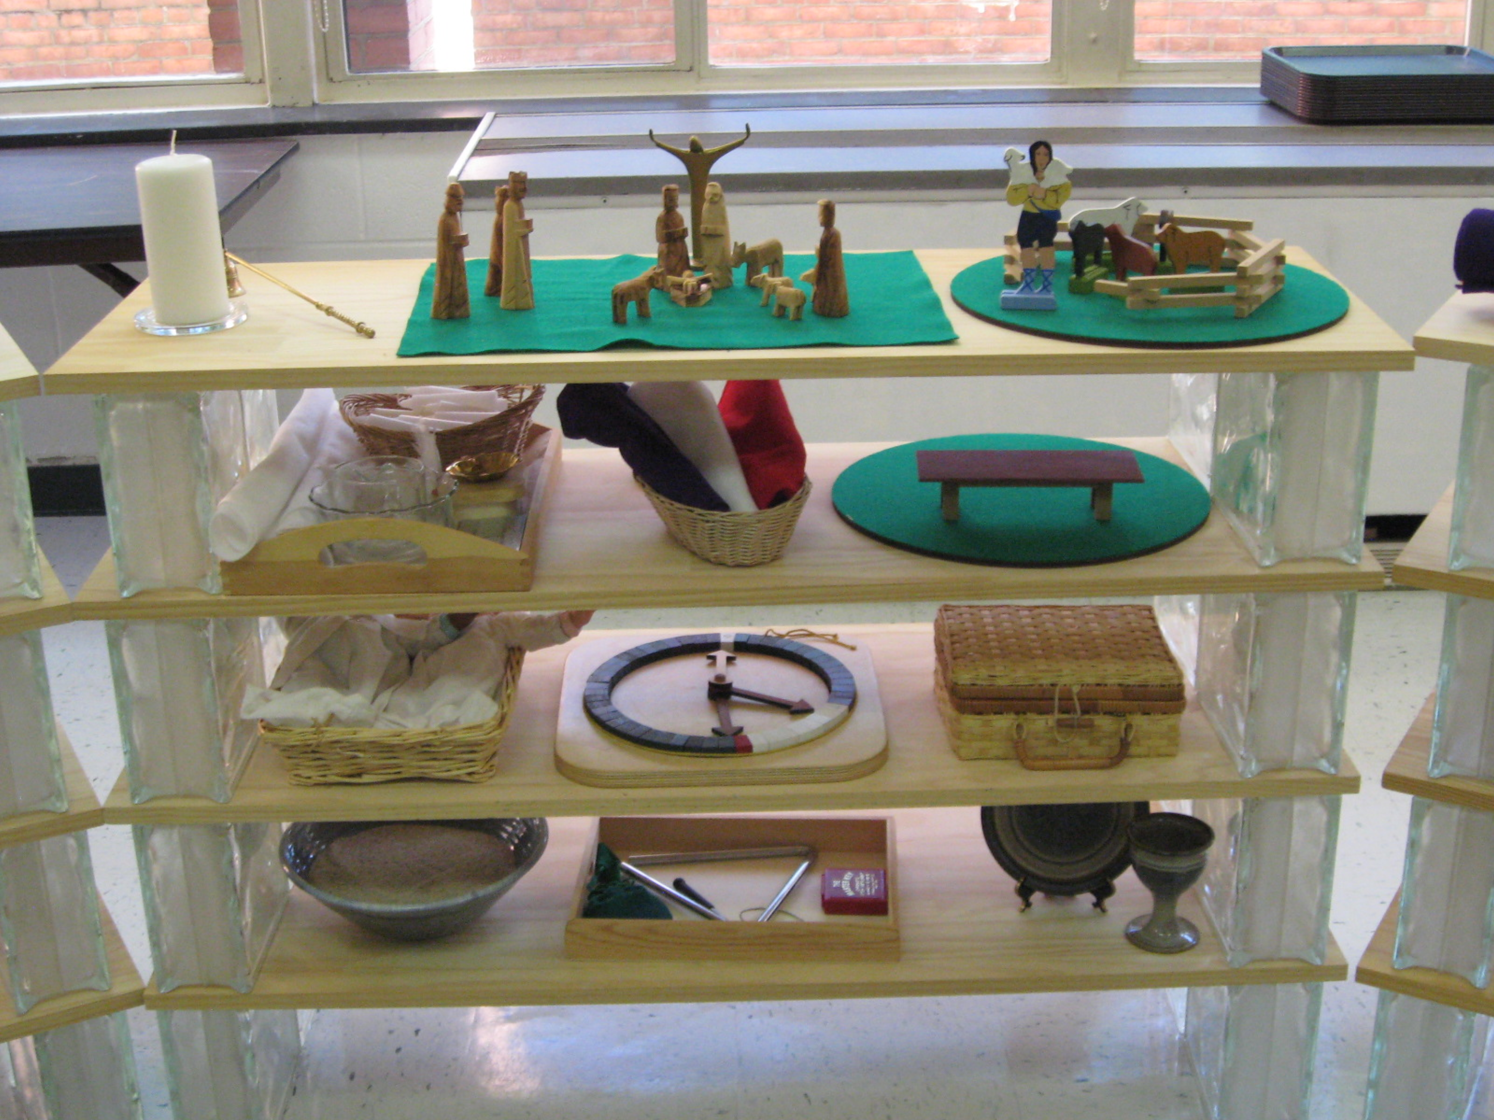

Focal shelf, Washington DC

