Northsiders with Refugees: Wills Candidates Forum

On Tuesday the 23rd April from 6.00 - 7.30 pm in Brunswick, we're hosting a meet the candidates forum on asylum policy and we'd love you to join us!
Right now, there are over 24,000 people seeking asylum living in our communities and in indefinite detention who've been waiting, some for 10 years, to have their refugee claims assessed. While they wait many have been denied the right to work, relying on income support which the Government has now cut, leaving thousands of men, women and their children destitute and homeless.
This federal election we can change that!
The success of the #KidsOffNauru Campaign is proof that when communities come together to demand our Government treats people with fairness and decency - our Parliament listens.
Join us to hear from sitting member, Labor MP Peter Khalil, Adam Pulford (Greens), Sue Bolton (Victorian Socialists), Manju Venkatswamppa (United Australia) and independent candidates, as they explain their policies and answer your questions.
Together, lets make sure our candidates know people seeking asylum and refugees are a decisive issue for the Wills community this federal election.
To join us and get updates on our venue, RSVP here.
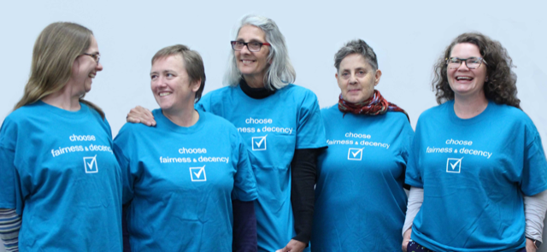
See also: https://www.facebook.com/northsiderswithrefugees/

