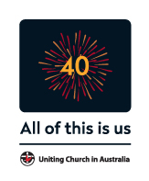

Uniting Church
in Australia

Pastoral Statement

14 December 2017

Honouring our Commitment to Child Safety

Dear Brothers and Sisters in Christ,

Five years after its announcement, Australia’s landmark Royal Commission into Institutional Responses into Child Sexual Abuse has handed its Final Report to Government.

On this occasion I want to acknowledge the extensive and invaluable body of work produced by the Royal Commission and its staff, and remind all Church members of our solemn commitment to child safety that is informed by the Commission’s work.

As Chief Commissioner Justice Peter McClellan AM warned at the Royal Commission’s final sitting, the sexual abuse of children is not just a problem from the past.

Justice McClellan said: “Poor practices, inadequate governance structures, failures to record and report complaints, or understating the seriousness of complaints, have been frequent.”
He went on to say: “If the problems we have identified are to be adequately addressed, changes must be made. There must be changes in the culture, structure and governance practices of many institutions.”
The Uniting Church in Australia will consider the Royal Commission’s Final Report carefully, reflect on its findings and recommendations, and implement measures to deliver the best quality of care, service and support for children.

At this time, I would again like to sincerely apologise to all children in our care who suffered sexual abuse in our Church, whether it happened after our foundation in 1977 or before that, in our predecessor Churches.

We are, and I am, deeply sorry that we did not protect and care in accordance with our Christian values for those children. I again want to acknowledge the impact that it’s had in the lives of those young people and their families, and to say that I am truly sorry.

We must never forget the courage of survivors who’ve come forward to tell their stories in public and in private. The Uniting Church will continue to work constructively with Government and other stakeholders for a truly national redress scheme, as the most equitable way to support survivors wherever they might be.

Our Church’s commitment is that we will seek to make amends and strive to ensure others will not suffer as they have. Our prayers and a determined focus will be required if we are to build a robust culture of child safety.

With the collaboration of Synods and many others across our Church, we have begun applying the learnings of the Royal Commission through a National Child Safe Policy Framework. The work of implementation will continue to be resourced into the future through the National Royal Commission Task Group and support staff, who will work to incorporate the recommendations of the Final Report in the weeks and months ahead.

I urge all Church members to remain vigilant, to ensure that wherever you are in our Church, agencies or schools, you are focussed on child safety. If you are a Church member and would like information about safe church training, please contact your Synod or Presbytery.

In the years ahead, may God grant us the strength and wisdom to honour our pledge to be the safest church we can be for children, and for all people in our midst.

Marrkapmirri,
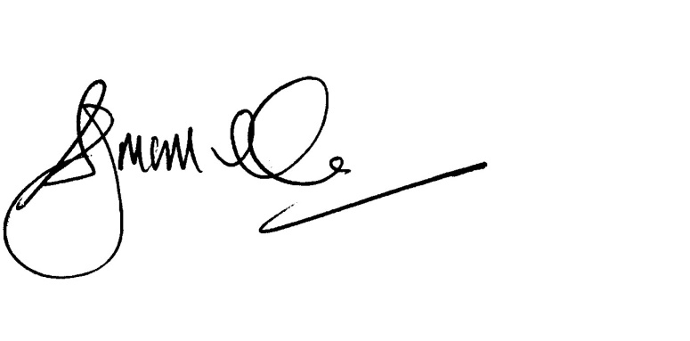
Stuart McMillan
President

Marrkapmirri means deep affection, love as with a brother or sister, in the Yolŋu languages of North East Arnhem Land.

Discussing these issues can raise difficult emotions and past memories.

If you or someone you know needs help, please call:

1800 RESPECT (1 800 737 732)
Lifeline on 13 11 14
Kids Helpline on 1800 551 800
MensLine Australia on 1300 789 978
Suicide Call Back Service on 1300 659 467

Royal Commission into Institutional Responses to Child Sexual Abuse

Prayers for personal use or corporate worship
Ministers are invited to use this prayer within intercessory prayers on Sunday 17 December 2017.

For those who have experienced abuse

Gracious and healing God,
we thank you for the many ways that you enrich our lives - giving us hope in the midst of despair; comfort and strength to live,
when we are at our most vulnerable.
Be with all those who continue to suffer - living with brokenness and pain.

We particularly think of people who were sexually abused as children.
May your Spirit be a comforting and healing presence in their lives.
May they find peace within relationships and communities of safety and trust.

Give us the wisdom to bring your healing and hope in our relationships, neighbourhoods and communities.

Give us courage, insight, power and passion that we might work with you for justice and liberation of all those who were abused and oppressed.

And help us to honour survivors’ stories by ensuring our Church is the safest place we can make it for children in our care.

Lord, hear us
Lord, hear our prayer

For the Royal Commission

God of wisdom, we pray for all those who have served the Royal Commission,
that their work will be received and acted upon by institutions.

We give thanks for Royal Commission staff and their dedication and pray that their work will make our country a safer place for all children.

We ask that this Final Report and its recommendations will lead to healing and peace for those who have survived sexual abuse in the past, and for them to feel that justice has been done and hope restored.

Lord, hear us.
Lord, hear our prayer

For the church

Holy God, through Jesus your Son, in the power of the Spirit,
you brought your church into being.

The revelations and stories of these past five years have challenged us to respond in Christ-like ways,
Give us the strength of character to courageously and honestly face the mistakes of the past.

Help us all to confront and confess our failures that we may continue with integrity to speak out for truth and justice in our nation
and boldly declare the salvation promised to all who repent and believe in the good news revealed in Jesus your Son.

Lord, hear us.
Lord, hear our prayer

